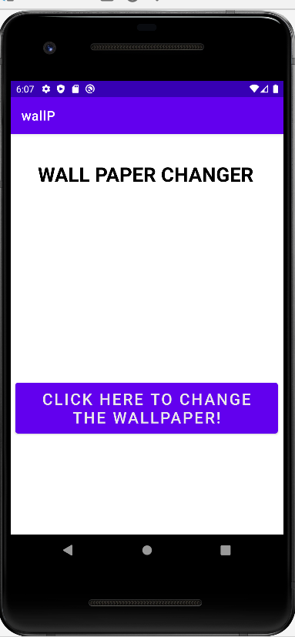 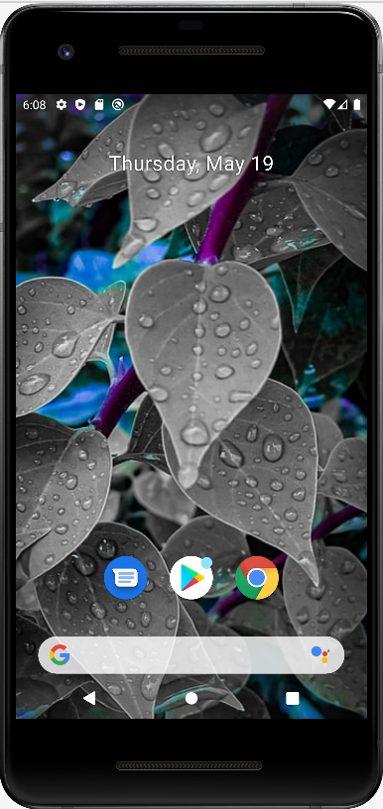 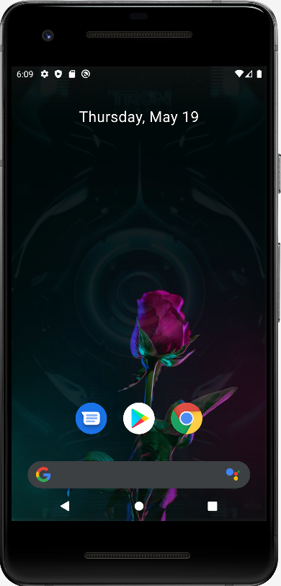 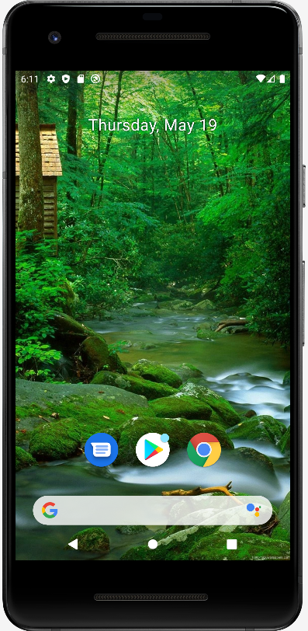

package com.example.lab04play;  
  
import androidx.appcompat.app.AppCompatActivity;  
  
import android.app.WallpaperManager;  
import android.graphics.Bitmap;  
import android.graphics.drawable.BitmapDrawable;  
import android.graphics.drawable.Drawable;  
import android.os.Bundle;  
import android.view.View;  
  
import java.io.IOException;  
import java.util.Timer;  
import java.util.TimerTask;  
  
public class MainActivity extends AppCompatActivity {  
 Timer myTimer;  
 Drawable drawable;  
 WallpaperManager wpman;  
 int nextImg = 1;  
  
 @Override  
 protected void onCreate(Bundle savedInstanceState) {  
 super.onCreate(savedInstanceState);  
 setContentView(R.layout.*activity_main*);  
  
 myTimer = new Timer();*//1. Initialize myTimer object* wpman=WallpaperManager.*getInstance*(this);*//2. Create an instance of the WallPaper manager* }  
  
 public void changeWallPaper(View view) {  
 setWallpaper();  
 }  
  
 private void setWallpaper() {  
 myTimer.schedule(new TimerTask() {  
 @Override  
 public void run() {  
 if(nextImg == 1)  
 {  
 drawable=getResources().getDrawable(R.drawable.*img1*);  
 nextImg = 2;  
 }  
 else if (nextImg==2)  
 {  
 drawable=getResources().getDrawable(R.drawable.*img2*);  
 nextImg = 3;  
 }  
 else if (nextImg==3)  
 {  
 drawable=getResources().getDrawable(R.drawable.*img3*);  
 nextImg = 4;  
 }  
 else if (nextImg==4)  
 {  
 drawable=getResources().getDrawable(R.drawable.*img4*);  
 nextImg = 5;  
 }  
 else if (nextImg==5)  
 {  
 drawable=getResources().getDrawable(R.drawable.*img5*);  
 nextImg = 6;  
 }  
 else if (nextImg==6)  
 {  
 drawable=getResources().getDrawable(R.drawable.*img6*);  
 nextImg = 7;  
 }  
 else if (nextImg==7)  
 {  
 drawable=getResources().getDrawable(R.drawable.*img7*);  
 nextImg = 1;  
 }  
  
 *//Create a BitMap Image..Why?* Bitmap img = ((BitmapDrawable) drawable).getBitmap();*//Cast the drawable into a BitMapDrawable object and assign it to img"Bitmap variable"  
  
 //Now set those images, YES you have to take permissions from the android manifest* try {  
 wpman.setBitmap(img);  
 } catch (IOException e) {  
 e.printStackTrace();  
 }  
 }  
 },30000,5000);  
 }  
}

package com.example.wallp;  
  
import androidx.appcompat.app.AppCompatActivity;  
  
import android.app.WallpaperManager;  
import android.graphics.BitmapFactory;  
import android.os.Bundle;  
import android.view.View;  
import android.widget.Button;  
  
import java.io.IOException;  
import java.util.Random;  
import java.util.Timer;  
import java.util.TimerTask;  
  
public class MainActivity extends AppCompatActivity implements View.OnClickListener {  
 Button btn;  
 boolean running;  
  
 *//To load all seven images at the same time, create an array of type in  
 //Iterate through them, OBSERVE: The images will be populated & displayed on the left Side* int[] imgC = new int[]{R.drawable.*img1*, R.drawable.*img2*, R.drawable.*img3*, R.drawable.*img4*,R.drawable.*img5*, R.drawable.*img6*, R.drawable.*img7*};  
  
 @Override  
 protected void onCreate(Bundle savedInstanceState) {  
 super.onCreate(savedInstanceState);  
 setContentView(R.layout.*activity_main*);  
  
 btn = (Button) findViewById(R.id.*button*);  
 btn.setOnClickListener(this);  
 }  
*//NOTE: CTRL+Q = Quick Documentation Lookup, CTRL+P = Parameters for Selected Method* @Override  
 public void onClick(View view) {  
 if(!running){ *// Refer Video for the timer explanation* new Timer().schedule(new myTimer(), 0, 3000);*//create an object of Timer()* running = true;  
 }  
 }  
  
 private class myTimer extends TimerTask {  
 @Override  
 public void run() {  
 try{ *//Try to Handle the Exception by using the WallPaperManager class* WallpaperManager wallpaperManager = WallpaperManager.*getInstance*(getBaseContext());  
 Random random = new Random();*//Creates an Object of Random Class  
 //OBSERVATION: This was changinging randomly. That's incorrect, so, we need a better approach* wallpaperManager.setBitmap(BitmapFactory.*decodeResource*(getResources(),imgC[random.nextInt(7)]));  
 *//It will turn Red, make sure you enable Permission* } catch (IOException e) {  
 e.printStackTrace();  
 }  
 }  
 *//It will show RED Underline, you have to RightClick->Show Context Action->Implement Run Methods  
 //and the error will be gone* }  
}